**Overview**

* A highly available and scalable Domain Name System (DNS) web service used for domain registration, DNS routing, and health checking.
* If you have used the Internet, you have used DNS. DNS is used to convert human friendly domain names(For ex: google.com) into Internet Protocol (IP) address(such as [http://82.23.45.67](http://82.23.45.67/)).
* It is a Phonebook for the Internet.
* IP addresses are used by computers to identify each other on the network. IP addresses are commonly comes in 2 forms, IPv4 and IPv6.

**IPv4 vs IPv6**

* The IPv4 space is a 32 bit field and has over 4 billion different addresses (4,294,967,296 to be precise).
* IPv6 was created to solve this depletion issue and has an address space of 128 bits which in theory is 340,282,366,920,938,463,463,374,607,431,768,211,456 addresses or 340 undecillion addresses

**Top Level Domains**

* .com,.edu,.gov are top level domain names whereas .co.uk, .com.au are second level domains
* These top level domains are controlled by the Internet assigned numbers authority (IANA) in a root zone database which is essentially a database of all available top level domains
* http://www.iana.org/domains/root/db

**Domain Registrars**

* Because all of the names in a given domain name have to be unique there needs to be a way to organize this all so that domain names are not duplicated. This is where domain registrars come in.
* A registrar is an authority that can assign domain names directly under one or more top-level domains.
* These domains are registered with InterNIC, a service of ICANN, which enforces uniqueness of domain names across the internet.
* Each domain name becomes registered in a central database known as the WhoIs database.
* Popular domain Registrars include
  + GoDaddy.com
  + 123-reg.co.uk
  + Amazon
  + Google
  + Microsoft

**Domain Registration**

Choose a domain name and confirm that it’s available, then register the domain name with Route 53. The service automatically makes itself the DNS service for the domain by doing the following:

Creates a hosted zone that has the same name as your domain.

Assigns a set of four name servers to the hosted zone. When someone uses a browser to access your website, such as www.example.com, these name servers tell the browser where to find your resources, such as a web server or an S3 bucket.

Gets the name servers from the hosted zone and adds them to the domain.

If you already registered a domain name with another registrar, you can choose to transfer the domain registration to Route 53.

Enable DNSSEC signing on new or existing public hosted zones. DNSSEC provides data integrity verification and data origin authentication for DNS.

You can also configure DNSSEC on domain registration.

**Routing Internet Traffic to your Website**

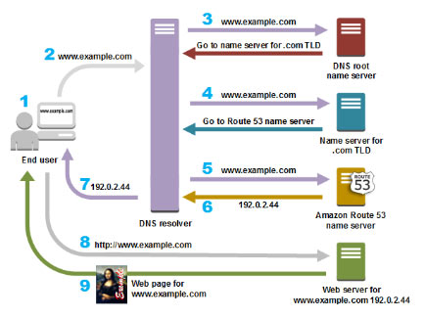

* Use the Route 53 console to register a domain name and configure Route 53 to route internet traffic to your website or web application.
* After you register your domain name, Route 53 automatically creates a **public hosted zone** that has the same name as the domain.
* To route traffic to your resources, you create **records**, also known as *resource record sets*, in your hosted zone.
* You can create special Route 53 records, called **alias records**, that route traffic to S3 buckets, CloudFront distributions, and other AWS resources.
* Each record includes information about how you want to route traffic for your domain, such as:
  + Name – name of the record corresponds with the domain name or subdomain name that you want Route 53 to route traffic for.
  + Type – determines the type of resource that you want traffic to be routed to.
  + Value

**Start of Authority Record (SOA)**

* All the DNS has Start of Authority (SOA) Record. The SOA Record stores information about
  + The name of the server that supplied the data for the zone.
  + The administrator of the zone.
  + The current version of the data file.
  + The default number of seconds for the time-to-live file on resource records.

**NS Records**

* NS stands for Name Server records.
* They are used by Top Level domain servers to direct traffic to the Content DNS server which contains the authoritative DNS records.
* servers in the DNS that help to translate domain names into the IP addresses that computers use to communicate with one another.

**Routing Policies**

* When you create a record, you choose a routing policy, which determines how Amazon Route 53 responds to queries:
  + Simple Routing
  + Weighted Routing
  + Latency-based Routing
  + Failover Routing
  + Geolocation Routing
  + Multi value Answer Routing

**Simple Routing Policy**

* This is the default Routing policy when you create a new record set. This is most commonly used when you have a single resource that performs a given function for your domain, for ex: one web server that serves content for the [http://google.com](http://google.com/) website
* You can’t create multiple records that have the same name and type, but you can specify multiple values in the same record, such as multiple IP addresses.

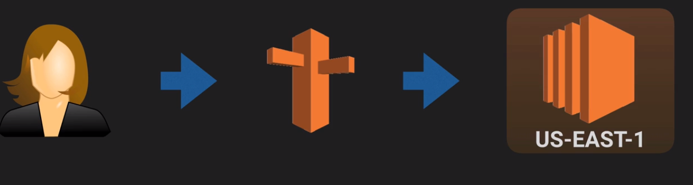

**Weighted Routing Policy**

* Weighted Routing Policies let you split your traffic based on different weights assigned.
* Use to route traffic to multiple resources in proportions that you specify.

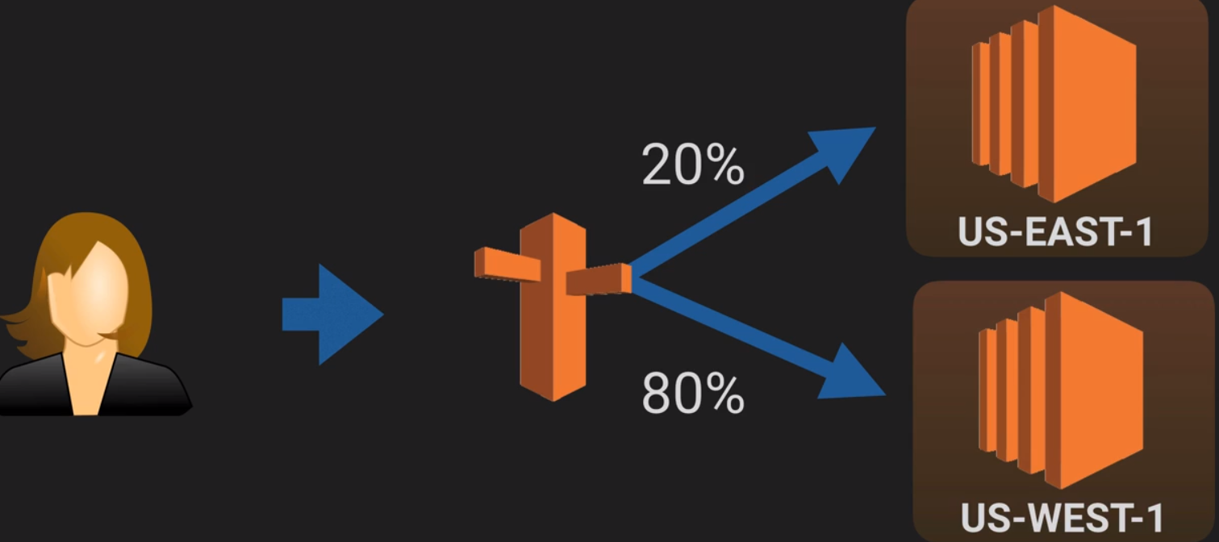

* For example, if you want to send a tiny portion of your traffic to one resource and the rest to another resource, you might specify weights of 1 and 255. The resource with a weight of 1 gets 1/256th of the traffic (1/(1+255)), and the other resource gets 255/256ths (255/(1+255)). You can gradually change the balance by changing the weights. If you want to stop sending traffic to a resource, you can change the weight for that record to 0.

**Latency Based Routing**

* Latency based routing allows you to route your traffic based on the lowest network latency for your end user(i.e which region will give them the fastest response time).
* Use when you have resources in multiple locations and you want to route traffic to the resource that provides the best latency.

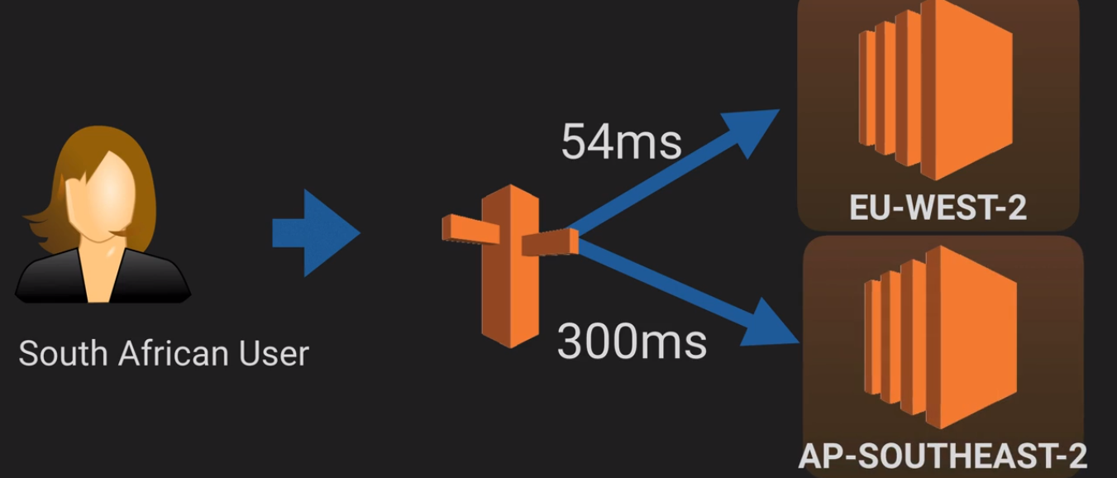

**Failover Routing Policy**

* Failover routing policies are used when you want to create an active/passive setup.
* For ex: you may want your primary site to be in EU-WEST-2 and your secondary DR site in AP-SOUTHEAST-2
* Route53 will monitor the health of your primary site using a health check. A health check monitors the health of your end points.

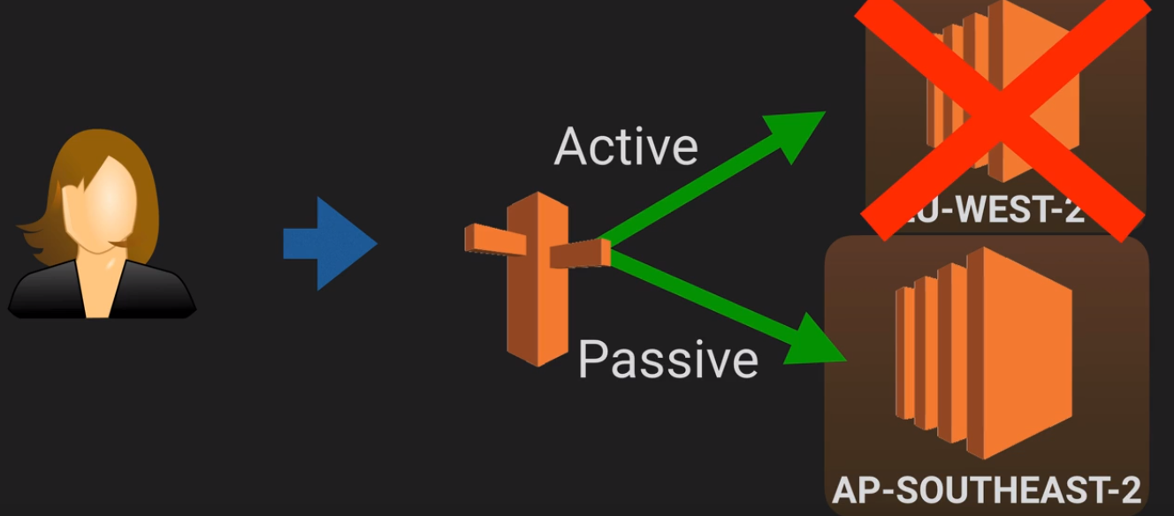

**Geolocation Routing Policy**

* Geolocation Routing lets you choose your traffic will be sent based on the geographic location of your users (i.e the location from which DNS queries originate)

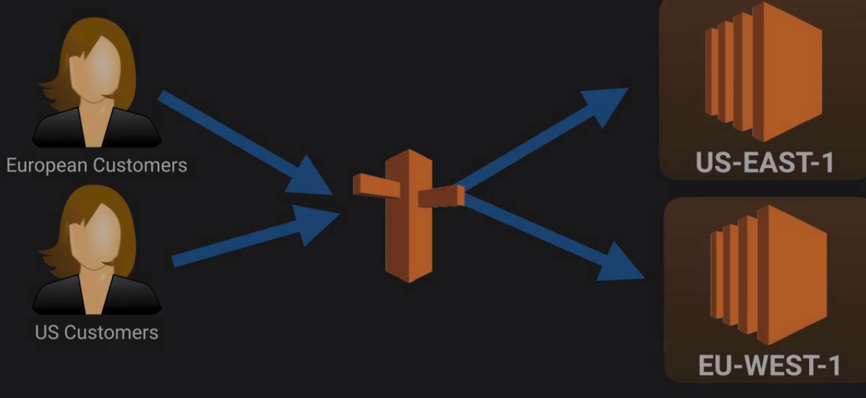

**Multivalue Answer**

* If you want to route traffic approximately randomly to multiple resources, such as webservers, you can create one multivalve answer record for each resource and optionally associate an Route 53 health check with each record.
* Multiple values can be specified for almost any record. Route 53 automatically performs health-checks on resources and only returns values of ones deemed healthy.

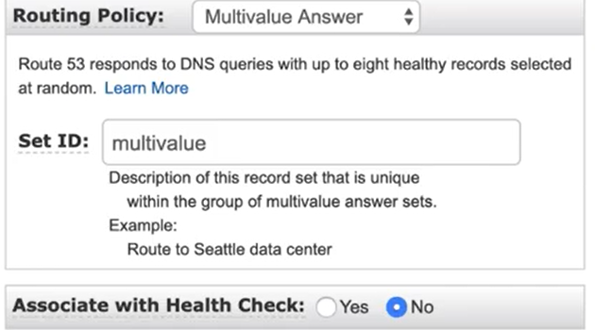

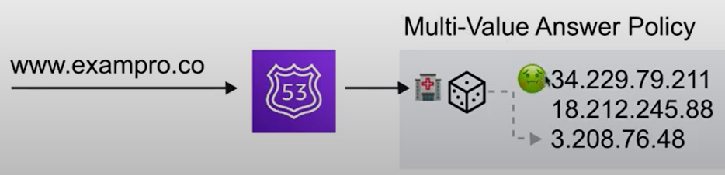

* Amazon Route 53 FAQs

<https://aws.amazon.com/route53/faqs/>

* Routing Traffic to an ELB Load Balancer

<https://docs.aws.amazon.com/Route53/latest/DeveloperGuide/routing-to-elb-load-balancer.html>

* Routing Policies

<https://docs.aws.amazon.com/Route53/latest/DeveloperGuide/routing-policy.html>

* Pricing

<https://d32ze2gidvkk54.cloudfront.net/Amazon_Route_53_Domain_Registration_Pricing_20140731.pdf>